Committee has conducted the following activities during the academic year 2017-2018
- Girl students participated in the fun walk on the theme “Women in Engineering” organised by GPREC Alumni (1992 batch) on 23rd July 2017.
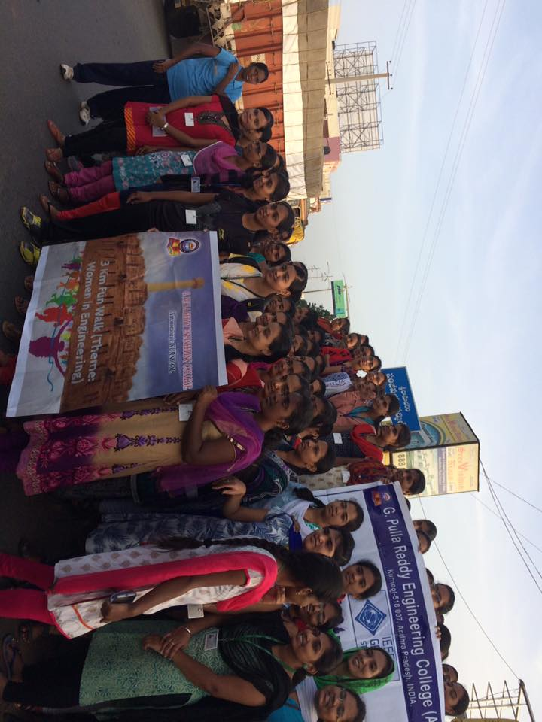
- A Workshop was organized on “Iam a Change Maker” by Sristhi Bakshi, Founder of Cross Bow and a Champion for Change on 17th November 2017.
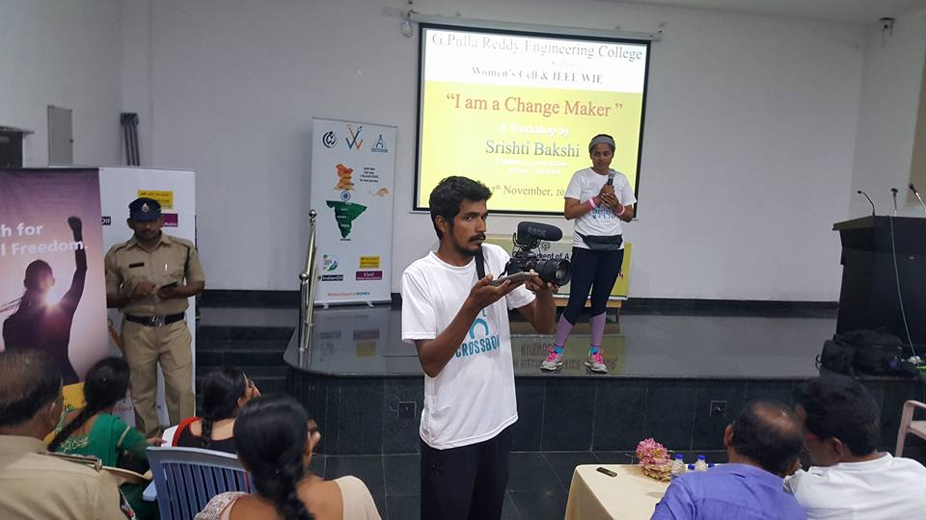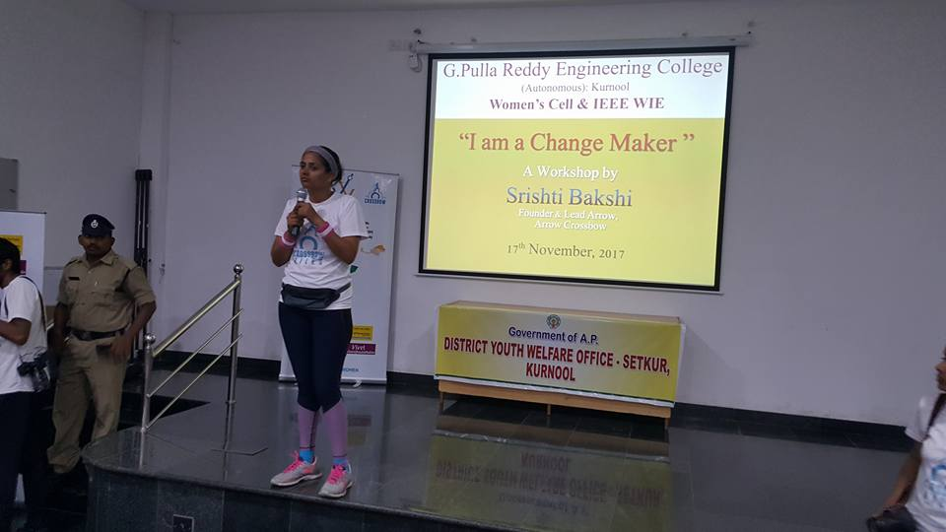
- A personality development program for girl students by Swami Anupamananda Maharaj, Secretary, Ramakrishna Mission Ashram, Tirupati, on 22nd December 2017.
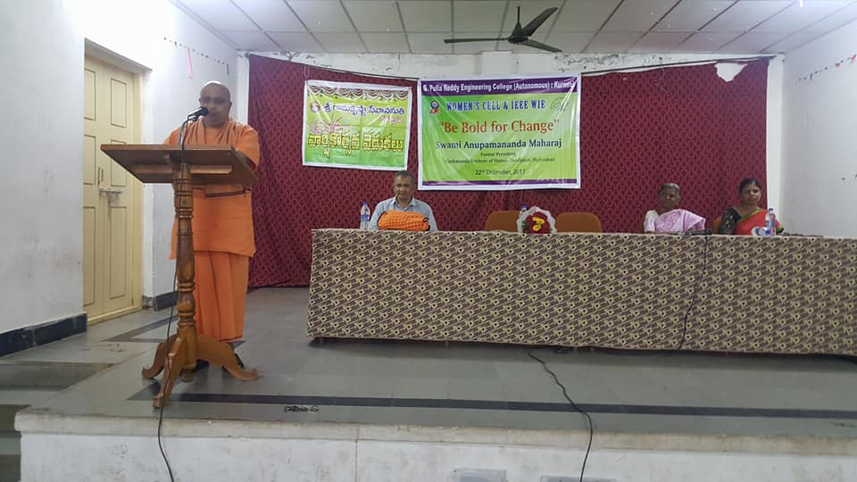
- An awareness program, in association with National Commission for Women, on ‘LEGAL RIGHTS OF WOMEN’ followed by an objective exam was organised on 6th and 9th October 2017 respectively. Smt. B. Jyothi, Senior Advocate in High Court and Miss S. K. Sphurthi, Junior Advocate in High Court addressed the students on legal rights of women. Eight cash prizes were awarded to the top eight students.
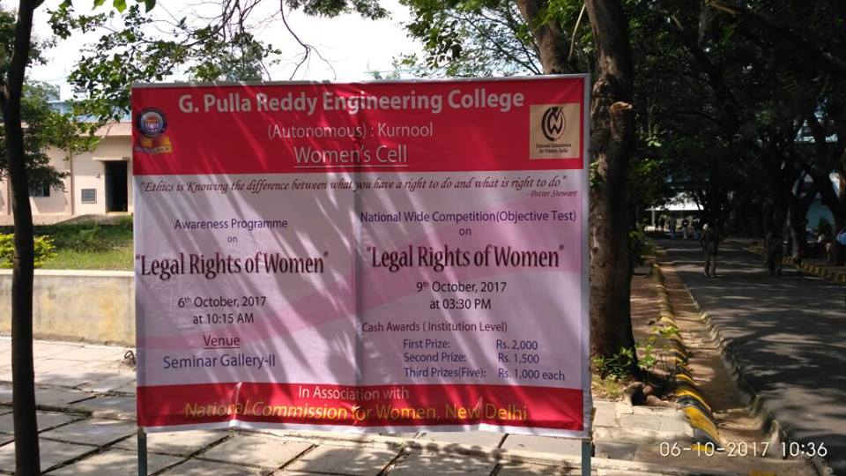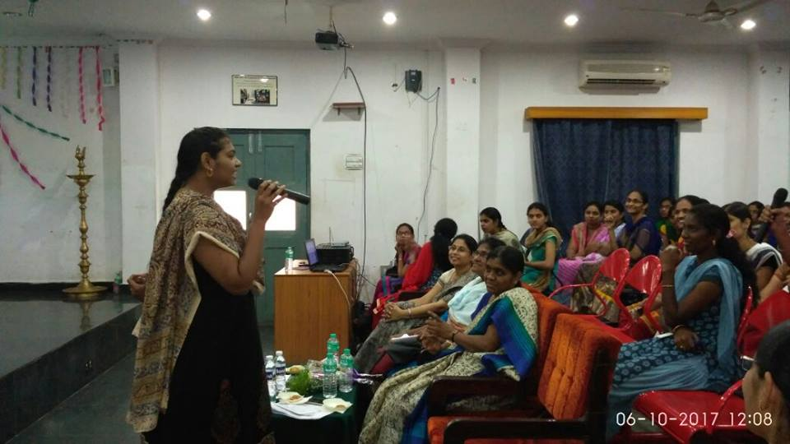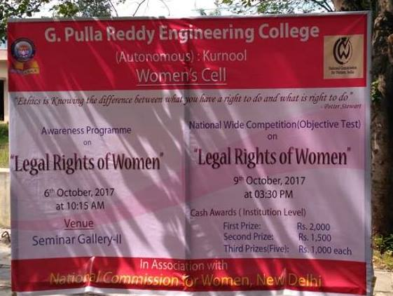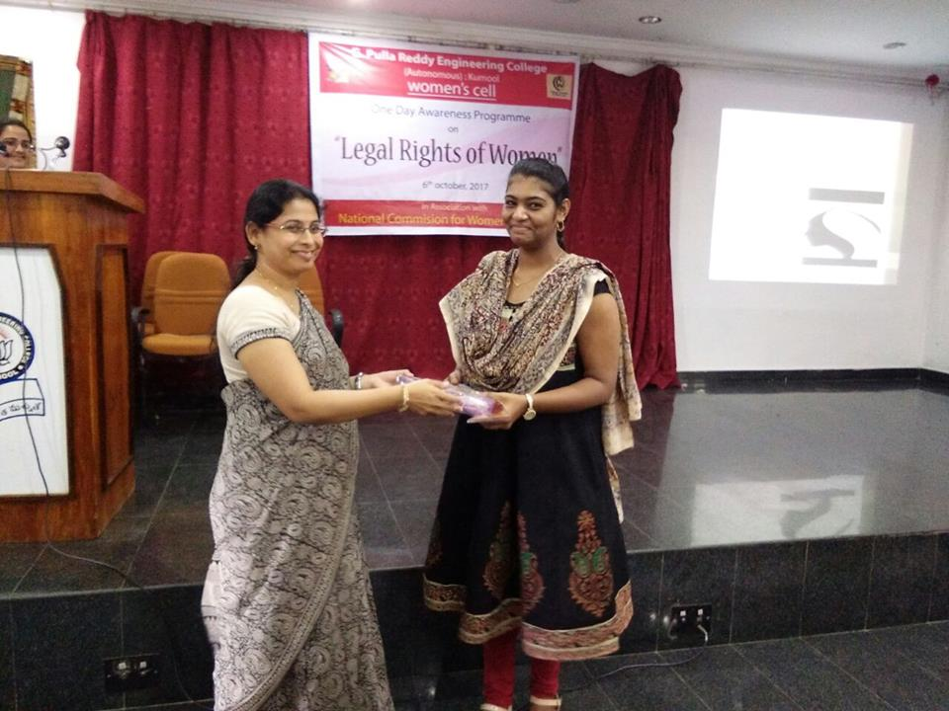
- A series of activities was conducted for selecting gender champion of GPREC from 27th December 2017 to 4th January 2018. Mona ElizebethVoola of III ECE bagged this award.
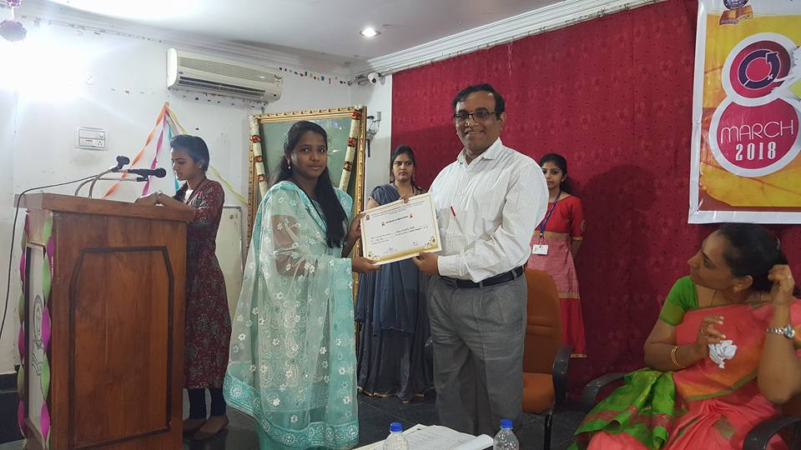
- Women’s cell also conducted best girl student contest on the campus based on their achievements on and off the campus. Miss Farhath Tabassum of ME bagged this award.
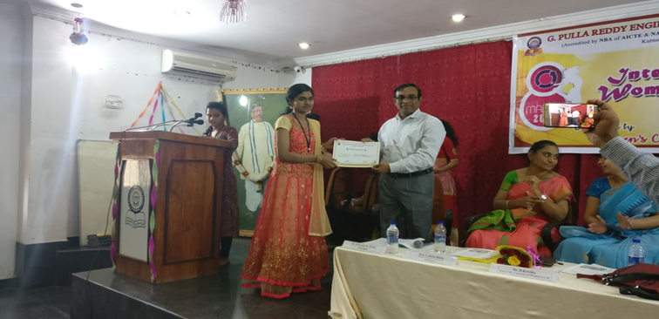
- On the occasion of IWD-2018, various competitions like story writing, connection, quiz and mehendi competition were conducted from 27nd February to 5th Match 2018, on the theme “#PRESS FOR PROGRESS”.
- International Women’s Day 2018 was celebrated on 8thMarch 2018 on the campus with the theme “#PRESS FOR PROGRESS”. Women’s cell annual magazine “SHE VOICE”, a collection of students’ articles was released by the chief guest Dr. Shobha Bindu, Professor of CSE, JNTUA, Ananthapuramu. Dr. Shobha addressed the girl students on women empowerment and its true utilization.
